Steps 1-5
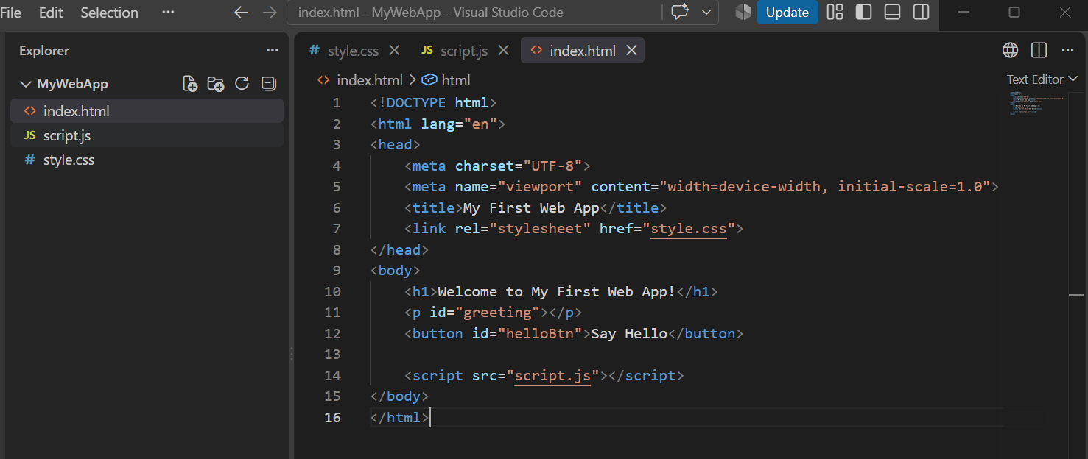
<!DOCTYPE html>
<html lang="en">
<head>
<meta charset="UTF-8">
<meta name="viewport" content="width=device-width, initial-scale=1.0">
<title>My First Web App</title>
<link rel="stylesheet" href="style.css">
</head>
<body>
<h1>Welcome to My First Web App!</h1>
<p id="greeting"></p>
<button id="helloBtn">Say Hello</button>

<script src="script.js"></script>
</body>
</html>

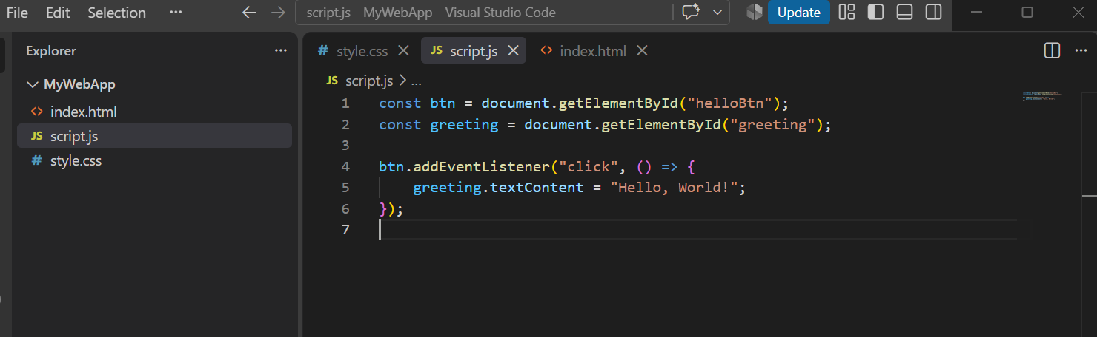
/* const btn = document.getElementById("helloBtn");
const greeting = document.getElementById("greeting");

btn.addEventListener("click", () => {
greeting.textContent = "Hello, World!";
}); */

const btn = document.getElementById("helloBtn");
const greeting = document.getElementById("greeting");

btn.addEventListener("click", () => {
greeting.textContent = "Hello, world!";

if (btn.style.backgroundColor === "green") {
btn.style.backgroundColor = "blue";
} else {
btn.style.backgroundColor = "green";
}
});

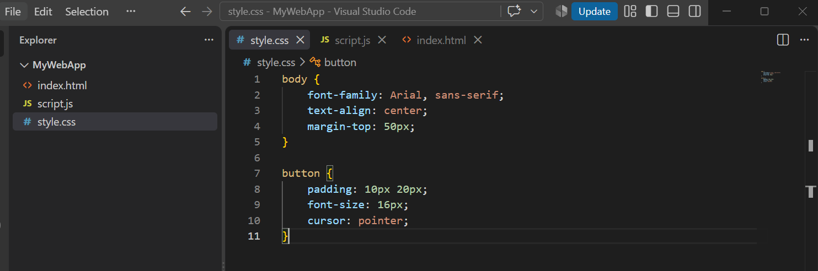
body {
font-family: Arial, sans-serif;
text-align: center;
margin-top: 50px;
}

button {
padding: 10px 20px;
font-size: 16px;
cursor: pointer;
}

Step 6
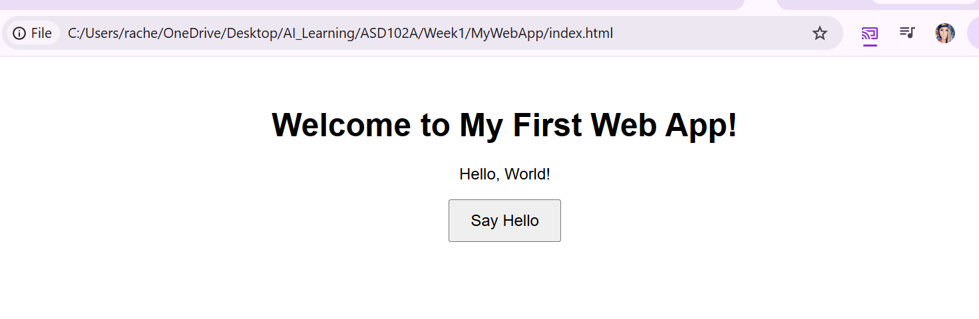
Step 7
2. 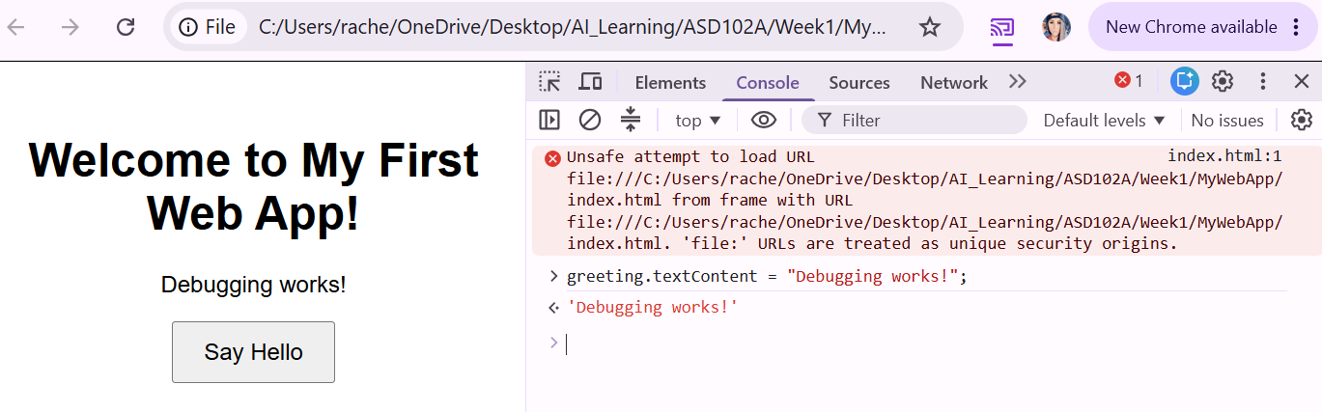
3. Nothing populated
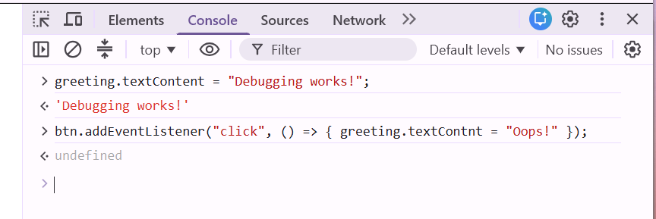
4.
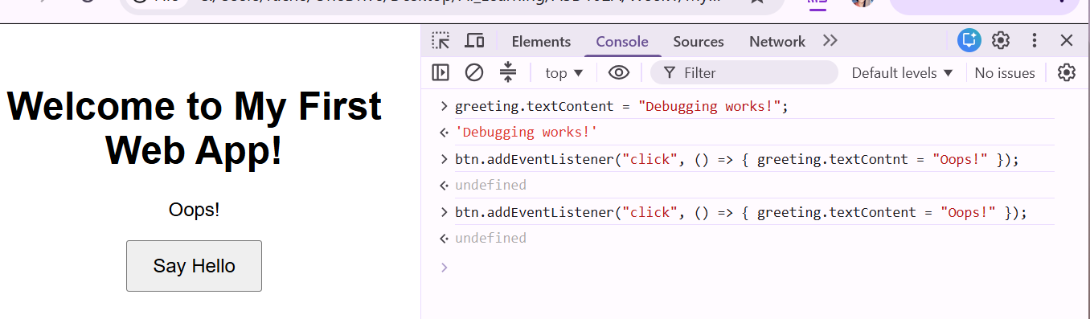

Step 8

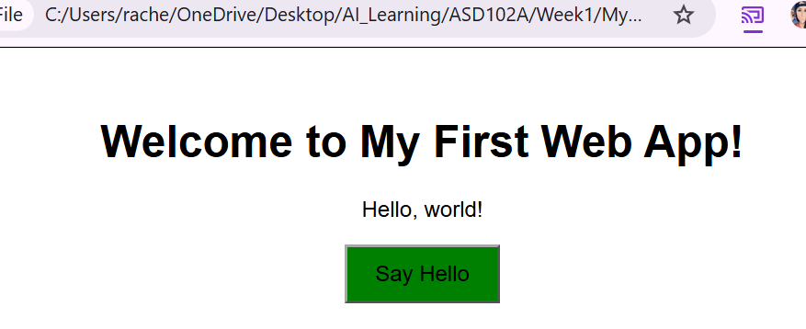
Step 9
https://github.com/RachelVSI/MyWebApp

